Mulesoft Deployment Guide

DAM (1st deployment)

|  |  |  |
| --- | --- | --- |
| **Date** | **Version** | **Description** |
| 2023-08-02 | v1 | Initial version |
|  |  |  |

**Author: Customer Self-Service team**

**Date: 02/08/2023**

I. Prerequisite 1

For Account Management 2

For Operation Team 2

II. Preparing Application Secrets (by Account Management) 2

Encrypt Mule Configuration File 3

III. Obtaining Platform Secret 4

IV. Create Mule App 5

V. Create Client Application 8

VI. Deploy Mule Application 10

# I. Prerequisite

## For Account Management

**Mule Application**

|  |  |  |
| --- | --- | --- |
| **Name** | **Description** | **Provided by** |
| css-hubspot-ms-api-v1.jar | Mule application | Application Team |

**Utilities (Account Management)**

|  |  |  |
| --- | --- | --- |
| **Name** | **Description** | **Provided by** |
| secure-properties-tool.jar | Config encryption tool | Application Team |

## For Operation Team

**Deployment Parameter / Secret Checklist**

|  |  |  |
| --- | --- | --- |
| **Identifier** | **Description** | **Provided by** |
| anypoint_client_id | Anypoint platform client ID for prod | Operation Team |
| anypoint_client_secret | Anypoint platform client secret for prod | Operation Team |
| Secure Key | The AES encryption key used by Account Management team for encrypting configuration files | Account Management Team |
| JWT Public Key | The JWT public key for JWT validation API policy | Application Team |

# II. Preparing Application Secrets (by Account Management)

## Encrypt Mule Configuration File

1. Ensure the following files are in the same folder

|  |  |
| --- | --- |
| **Filename** | **Remark** |
| secure-properties-tool.jar | Provided by the application team |
| prod_config.properties | Provided by the application team |

1. Open a command prompt
2. Change the current location to the folder in step 1
3. Generate an AES key with the following command

**openssl enc -aes-128-cbc -k secret -P –pbkdf2**

1. Copy key generated and safeguard this key

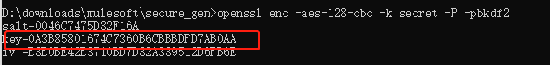

1. Open the file **prod_config.properties** with text editor (to be provided by application team)
2. Enter the fields that require encryption



1. Run the following command to encrypt the configuration file (replace **<key>** with the generated key)

**java -cp secure-properties-tool.jar com.mulesoft.tools.SecurePropertiesTool file encrypt AES CBC <key> prod_config.properties prod_secure_config.properties**

1. Ensure the **prod_secure_config.properties** is generated at the same folder
2. Ensure the content of the generated file is encrypted



1. Send the generated file to the application team

# III. Obtaining Platform Secret

Log in to **Anypoint Platform**

Click **Access Management**

Click the **Organization** tab

Click on the name of your organization or corresponding Business Group

Copy the **Client ID** and **Client Secret**

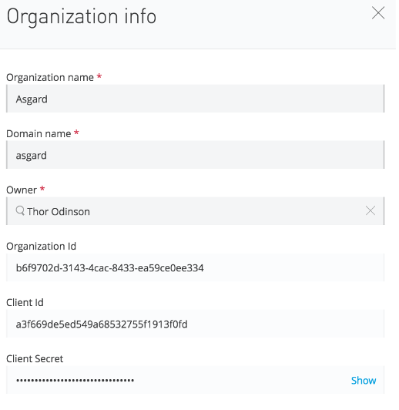

# IV. Create Mule App

1. Login to the **Anypoint Platform**
2. Navigate to the **API Manager**

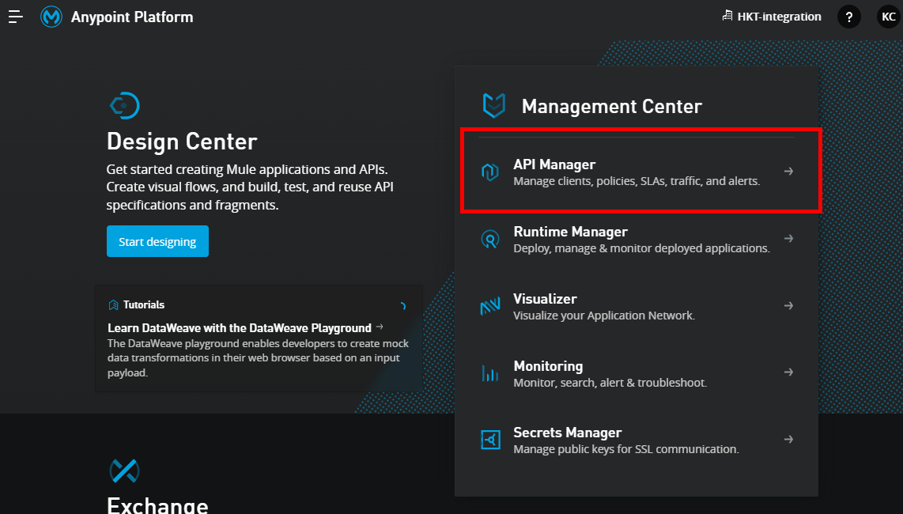

1. Click the environment selector

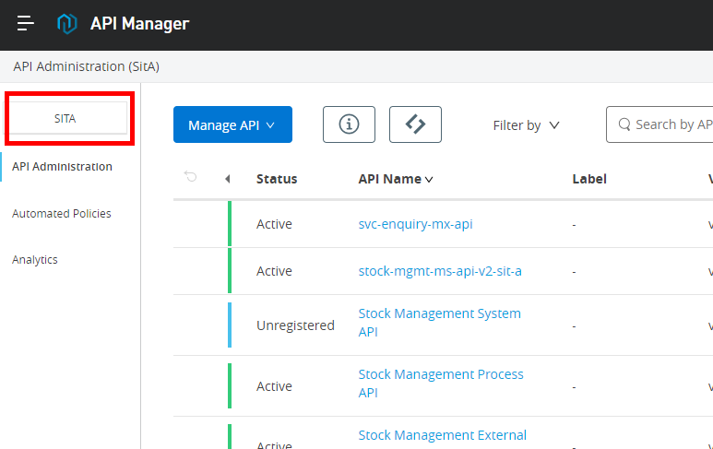

1. In the popup, select **Production**
2. Click **Add API**
3. Click **Add New API**

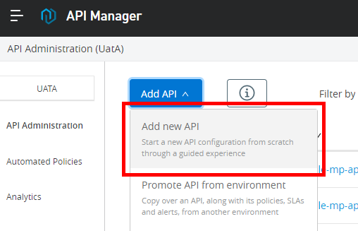

1. Select **Mule Gateway**
2. Click **Next**

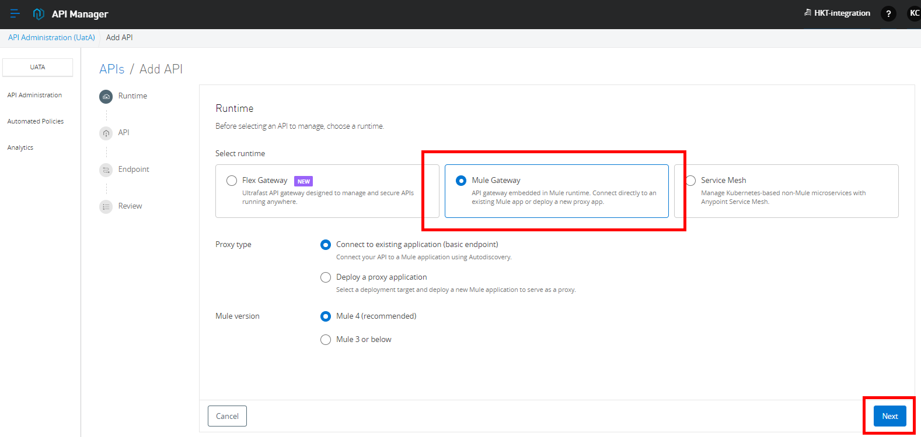

1. Search **CSS Hubspot System API**
2. Select **CSS Hubspot System API**

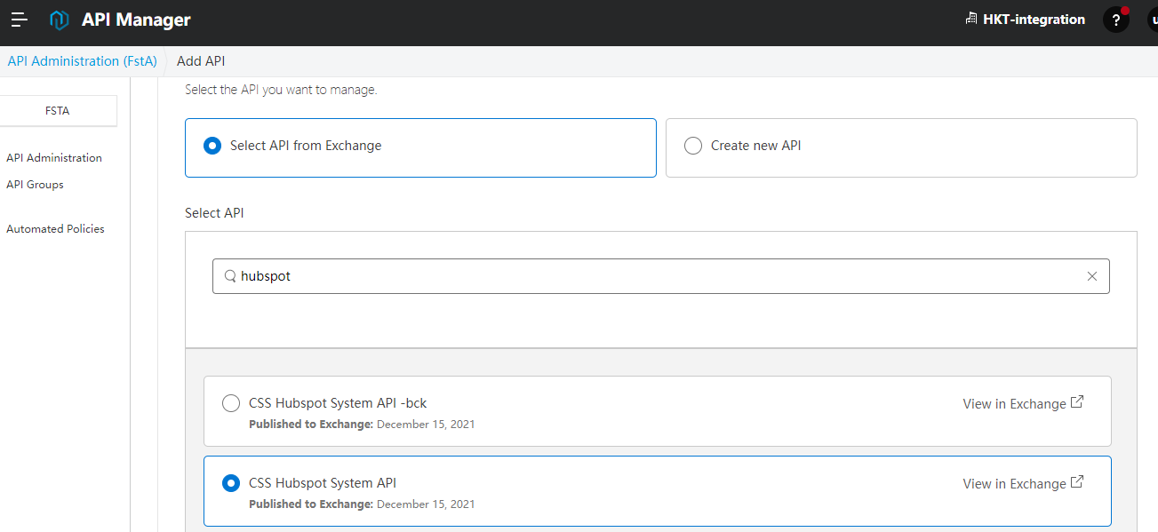

1. Click **Next**
2. For **API instance label**, enter: **prod**

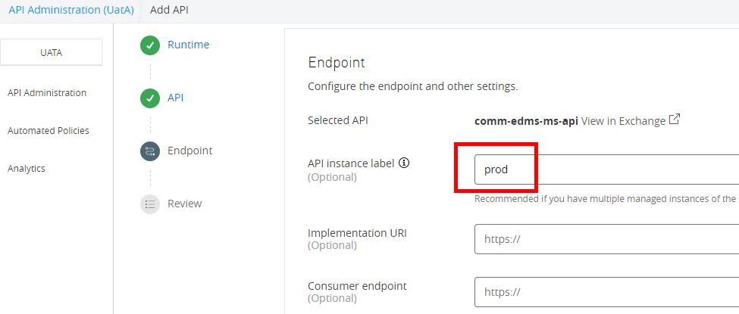

1. Click **Next**
2. Click **Save**
3. Copy the **API ID** then pass it to the **Application Team**

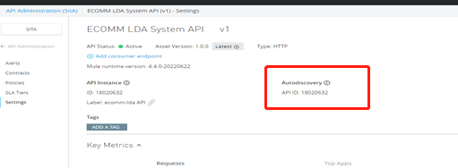

1. Go to **Policies** in the left-panel
2. Click **Add Policy**
3. Find and click **JWT Validation**
4. Click **Next**
5. For the field **JWT Key**, input the value of **JWT Public Key** (provided by application team)
6. For the field **Client ID Expression**, input: **#[vars.claimSet.sub]**
7. **Check** the flag **Validate Audience Claim**
8. **Check** the flag **Audience Claim Mandatory**
9. **Check** the flag **Expiration Claim Mandatory**
10. Click **Save**

# V. Create Client Application

1. Navigate to **Exchange**
2. Search for **CSS**
3. Find and click **CSS Hubspot System API** (HKT-integration)

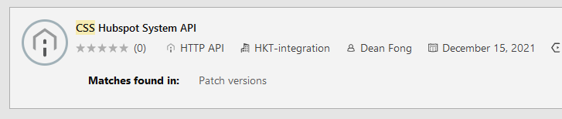

1. Click **Request Access**

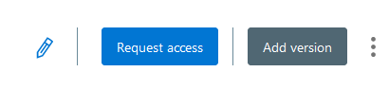

1. For **API Instance**, select **Production**
2. For **Application**, select **Create a new application**
3. For **Application Name**, input **css-hubspot-system-api-prod**
4. Click **Create**
5. Click **Request Access**
6. Copy the generated **Client ID** and **Client Secret** and pass to application team

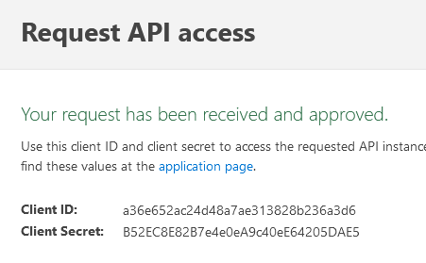

1. Go back to **API Manager**
2. Find and click **CSS Hubspot System API**
3. Click **Policies**
4. Edit the policy **JWT Validation**

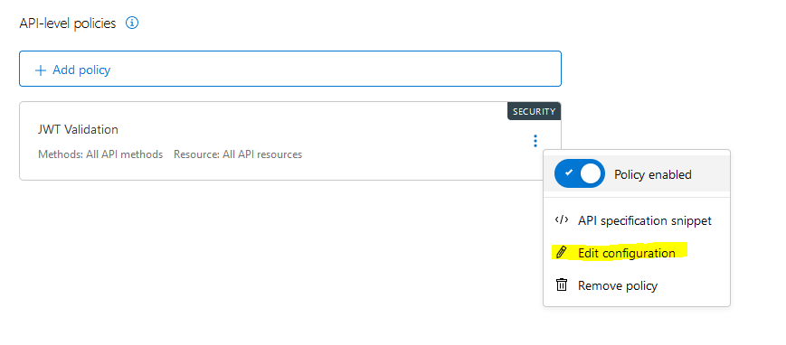

1. For the field **Audience Claim Values**
2. Input the previously generated **Client Secret**
3. Click **Save**

# VI. Deploy Mule Application

1. Navigate to **Runtime Manager**

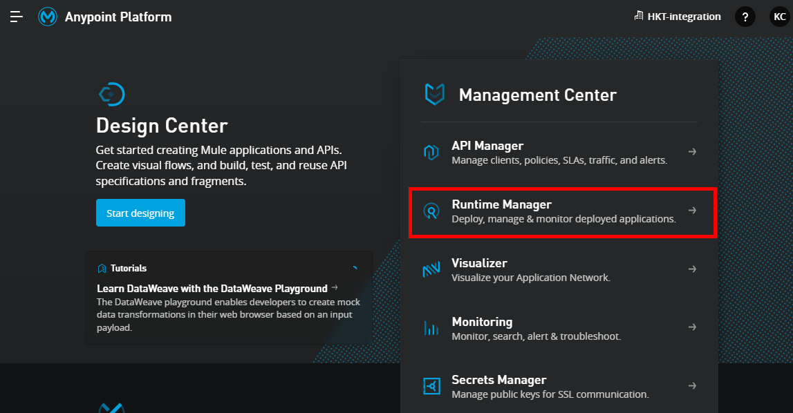

1. Click the environment selector

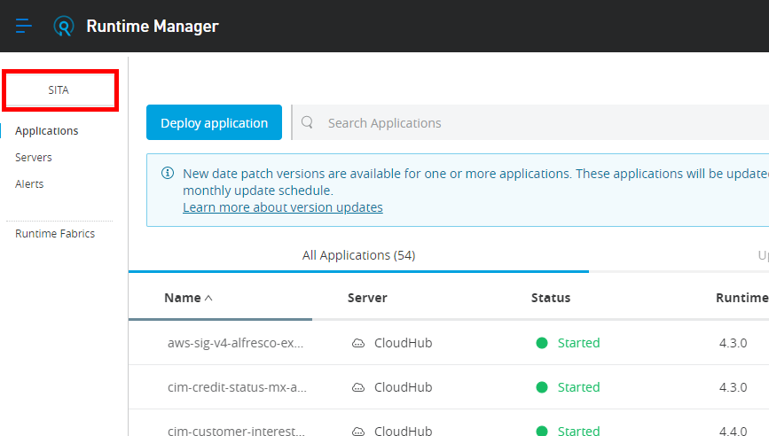

1. In the popup, select **Production**
2. Click **Deploy application**

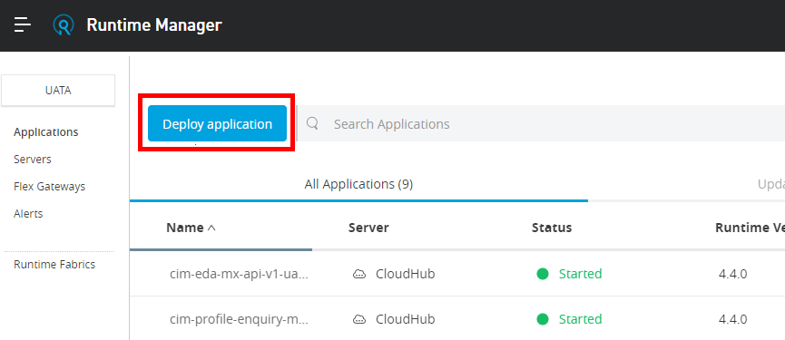

1. For **Application Name**, Enter **css-hubspot-ms-api-v1**
2. For **Deployment Target**, choose **Cloub Hub** (not 2.0)
3. Click **Choose File** to expand the menu
4. Click **Upload file**

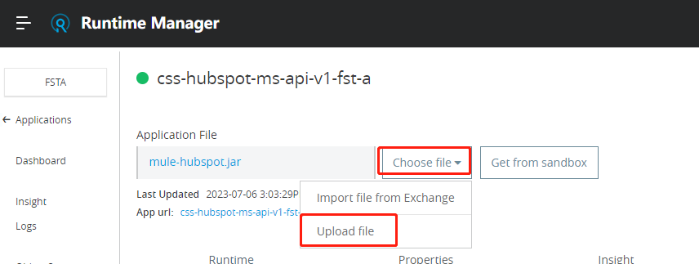

1. Upload the Mule application file **css-hubspot-ms-api-v1.jar**
2. Click the **Properties** tab

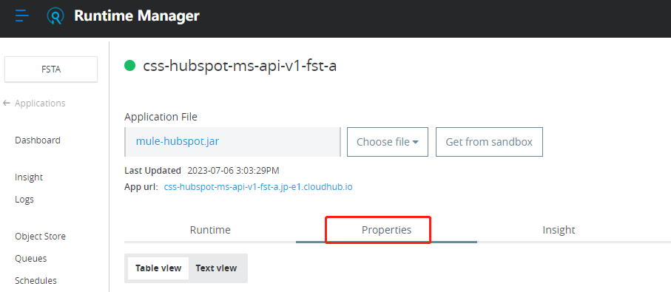

1. Insert / update the following key and values

|  |  |
| --- | --- |
| **Key** | **Value** |
| anypoint.platform.analytics_base_uri | https://analytics-ingest.anypoint.mulesoft.com/ |
| anypoint.platform.base_uri | https://anypoint.mulesoft.com/ |
| anypoint.platform.client_id | <Copy secret value **anypoint_client_id**> |
| anypoint.platform.client_secret | <Copy secret value **anypoint_client_secret**> |
| anypoint.platform.config.analytics.agent.enabled | true |
| api.id | <Copy the **API ID**> |
| env | prod |
| secure.key | <Copy the **Secure Key** from Account Management> |

1. Click **Deploy Application**
2. Wait until the Mule application upload completes
3. Navigate to the **Dashboard**

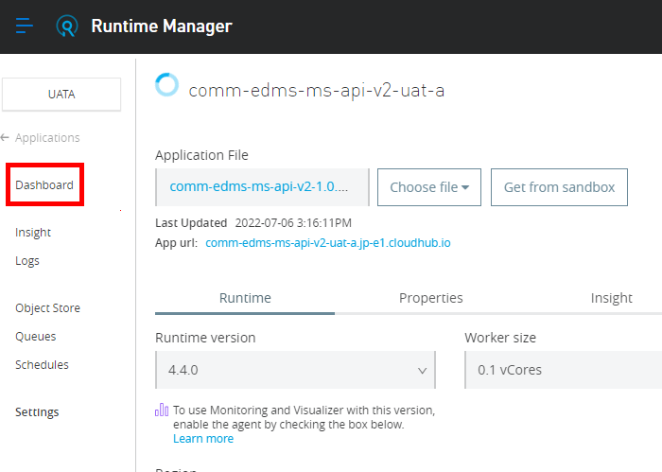

1. Wait until the status becomes **Started (green circle)**

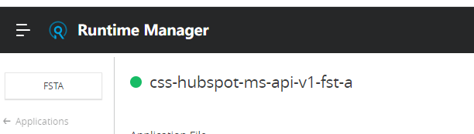

1. Delete the Mule application file from your local drive
2. If you deploy again after modifying the code,you can Click **Upload file** and upload the new jar package, then click on **Apply Changes** in the bottom right corner and Deployment will begin

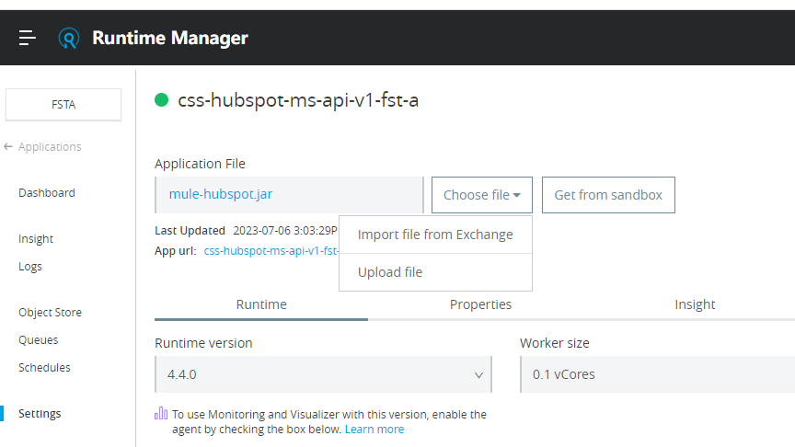

# VII. Troubleshoot

* If gateway timeout, disable JWT validation and enable again